**UNVEILING INSIGHTS: EXPLORING A MARKETING CAMPAIGN DATASET**

**CONTENT**

**-INTRODUCTION**

**-INSIGHTS**

**-RECOMMENDATION**

*-Web visits across the years.*

*-Purchases analysis by education.*

*-Campaign performance.*

*-Food and beverages purchase by age group.*

*-Purchase analysis by marital status.*

-**CONCLUSION**

**INTRODUCTION**

Businesses and companies are continuously striving to capture the attention of their target audience amidst a sea of competitors. Marketing campaigns serve as an avenue for these organizations to promote their services or products and engage with potential customers. However, in this data-driven era, the success of these campaigns depends not just on creativity but on the ability to utilize practical insights from the available data.

This is where marketing campaign analysis comes into play. By using analytical tools and techniques, companies can go deeper into defining the performance of their campaigns, and identify hidden trends and patterns that can influence strategic decision-making and lead to significant results.

From understanding consumer preferences to optimizing campaign targets, the insights derived from the campaign analysis will serve as a guide leading companies towards success in the competitive marketplace.

This article explores marketing campaign analytics through a Microsoft Excel dashboard built from a Marketing Campaign dataset that was sourced from Kaggle, an online community platform that hosts free public datasets contributed by researchers. The marketing campaign dataset consists of a wide range of variables such as Income, marital status, education, age, and campaign response indicator. These variables offer a deeper view into consumer behavior and campaign effectiveness.

To prepare the dataset for analysis, a check for duplicates was conducted and no duplicates were found. Additionally, in the education status column, the category previously labeled as '2n Cycle' was updated to 'Masters', and 'Graduation' was updated to 'Bachelor’s Degree'. For the Marital status column, 'Alone' was updated to 'Single', 'Widow' was updated to 'Widowed', and entries labeled as ‘YOLO’ and ‘Absurd’ were removed as they could not be added to the other categories, similar to how blanks were identified in the Income category and subsequently removed.

The dashboard provides an overview of the marketing campaign performance, enabling the easy and efficient identification of trends, patterns, and areas for optimization. The layout is designed to be easy to navigate with clear headings and organization of the charts. In this dashboard, visualizations such as bar charts, column charts, and line charts were used to compare the different variables in the dataset.

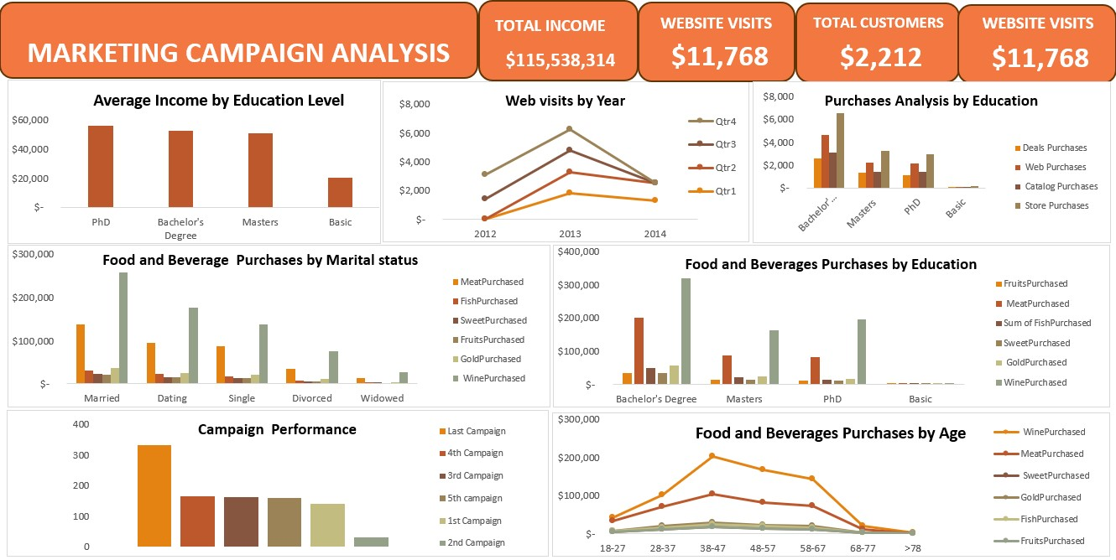

**INSIGHTS**

When the data was analyzed using the dashboard, several key insights and findings emerged, revealing trends, patterns, and correlations within the data.

* By categorizing the average income of the consumers by their Education level, PhD holders had the highest average income while the Basic certificate holders earned less.
* Throughout the year, the least amount of web visits was recorded during Q1 with a sharp increase in web visits by Q4.
* The education column was compared across the purchase channels (Web Purchases, Deals Purchases, Store Purchases, and Catalog Purchases), indicating that the Bachelor's Degree category made the most purchases directly from the store and the Basic degree holders made the least purchases across all channels.
* Married customers had the highest expenditure on products with wine being their primary purchase category, whereas widowed customers had the lowest spending.
* Compared to the first campaign, the last campaign had a higher response rate with an 8.59% increase in response. However, the response rate remained relatively low.
* Customers within the age range of 38-47 exhibit the highest purchase activity, with Wine emerging as the most purchased item. In contrast, those aged 68-78 made the lowest purchases.

**RECOMMENDATIONS**

The group of customers with the highest average income are the Ph.D. holders. Leveraging this information, premium product lines, exclusive offers such as limited-edition wines, and gourmet meats such as wagyu beef, and Iberico pork should be introduced. These items should be positioned as high-quality and luxury items that are appealing to this specific demographic. In addition, putting out articles, educational resources, and in-depth insights on topics related to wine, gourmet meats, and investment opportunities in gold, is expected to enhance the customer interest in the company and ultimately lead to an increase in purchase.

**WEB VISITS ACROSS THE YEARS**

The number of web visits plunged during Q1 across the years. To boost website traffic during this period:

* Develop content strategy focused on topics related to the Q1 season. Articles, blog posts, or videos related to the products that provide value and address the specific needs of the customers during this period should be created.
* Optimize the website for search engines to generate traffic and improve visibility to intending customers during Q1. Conduct research to identify key search terms and phrases related to the products during this time, optimize the website's content and images to rank higher in search engine results pages, and attract a targeted audience.
* Invest in paid advertising campaigns across different platforms such as Facebook, and Instagram to increase visibility and drive targeted traffic to the website.

During the fourth quarter(Q4) of the year, there is a significant increase in web visits. The Q4 typically consists of the following months: October, November, and December. These months cover the holiday season (Halloween, Thanksgiving, Christmas) making them a crucial period for sales. Special holiday promotions, personalized recommendations, discounts, exclusive deals, and limited-time offers should be offered to the customers, and gift packages featuring a selection of products should be positioned as the ideal gift ideas for family and friends during the holiday season. Extend operating hours, offer flexible delivery and same-day delivery to accommodate the busy shopping season to cater to last-minute customers and enhance convenience.

Also, anticipate the demand trends during the various seasons and ensure adequate product availability during the peak shopping periods. Monitor the sales data and recent developments to capitalize on new trends and preferences.

**PURCHASE ANALYSIS BY EDUCATION**

Across the purchase channels, the store channel emerged as the top performer, with the bachelor's degree holders making the highest number of purchases from the store. To further increase sales in the store:

* Offer in-store promotions, time-limited offers, and discounts to encourage customers to make additional purchases while visiting the store, create captivating display boards and advertising signs to highlight featured products, and promote impulse buys.
* Host in-store events like tasting, and product demonstrations to engage customers, partner with suppliers, and industry experts to showcase products and create a long-lasting experience for customers.
* Train staff to be knowledgeable about products, offer individualized recommendations and provide exceptional shopping experiences for the customers.
* Launch a loyalty reward scheme to reward repeat purchases and foster customer loyalty, offer points, discounts, or exclusive perks for in-store purchases to encourage customers to return to the store and accumulate rewards over time.

To increase sales across the web channel:

* Improve the user experience across the website and make it more visually appealing and easy to use for customers across different education levels. Provide clear product descriptions, and use simple language, icons, buttons, bullet points, and visual aids to portray product descriptions and benefits effectively.
* According to research, 71% of customers prefer ads tailored to them. Tailor website content and messages to resonate with specific customer segments. Create suggestions based on past purchases, browsing behavior, and demographic information to enhance the likelihood of a customer making purchases on the website
* Offer flexible payment options to cater to users with varying financial situations and preferences, accept major credit cards, digital wallets, and alternative payment options.
* Include customer reviews and testimonials from satisfied customers on the website to build credibility with potential buyers and reassure hesitant buyers.
* Not every website visitor will sign up or buy products on their first visit. To ensure that the customer returns to the website to make purchases, send reminders to the customer to complete their sign-up and use third-party websites to display ads and target customers that have visited the website before.
* Collect feedback on the website’s performance and provide continuous upgrades to improve the overall user experience and make the website shopping process seamless for all users.

**CAMPAIGN PERFORMANCE**

In comparison to the first campaign performance, there was a significant increase in response to the last campaign, although the overall response rate remained relatively low when considering the total number of customers. To increase the response to future campaigns:

* Explore additional marketing channels such as social media advertising, influencer partnerships, or content marketing to expand reach to new and potential customers.
* Properly identify the target audience to ensure that the campaign program reaches the relevant customer group. Analyze customer preferences and demographics to identify potential customers who are more likely to respond positively to marketing campaigns.
* Ensure the clarity of the campaign information to communicate efficiently the benefits of the company's products to every customer group. Use compelling language that resonates with the target audience and clearly states why they should purchase certain goods from the company.
* Offer exclusive promotions or rewards for customers who participate in campaigns and take desired actions such as buying a product or referring a friend.

**FOOD AND BEVERAGE PURCHASES BY AGE GROUP**

Based on the comparison of age groups and their respective food and beverage purchases, those within the age group of 38-47 had the highest purchasing activity. To enhance sales performance in this category:

* Create marketing campaigns tailored specifically to the interests and choices of the customers within that age group. Utilize the insights to make ads and promotions that will peak their interest leading to an increase in sales.
* Increase social media engagement by creating relevant and eye-catching content. Share lifestyle tips, recipes, and lifehacks that align with their interests, promoting sales among this demographic.
* Gather feedback directly from the 38-47 age group to have a better understanding of their preferences and complaints, and collect insights that can influence product development, marketing strategies, and overall growth of the business.

**PURCHASE ANALYSIS BY MARITAL STATUS**

Looking at the customers grouped by marital status, the married individuals made the most purchases in the food and beverages category. To further increase the sales in this category:

* Offer special discounts on food and beverage products that are mostly purchased by married couples, and offer deals that encourage customers to purchase multiple items at once like meal packages or complementary products to encourage them to spend more.
* Create marketing campaigns that appeal to married couples and families, focusing on how valuable, and quality the products are for celebrations, family gatherings, and everyday meals.
* Offer special deals and promotions tailored for married couples, like holiday-themed offers or seasonal recipes perfect for special occasions.

To drive additional sales among the other groups:

* Create marketing campaigns to cater to different marital status groups. Customize messages and promotions to match the unique preferences and lifestyles of married, single, divorced, and widowed folks.
* Create marketing campaigns suited for singles and those living alone. Include easy meals, single-serve options, and healthy choices that fit their lifestyle, focusing on simplicity and affordability.

**CONCLUSION**

Understanding customer preferences and behavior is fundamental for any successful marketing campaign. By delving into demographic insights, businesses can customize their strategies to better meet the needs of their target audience. So, whether it is through personalized deals, family-friendly packages, or seasonal discounts, there is always an avenue to make a long-lasting connection and drive sales.

**Data Source:** [**https://www.kaggle.com/code/sonalisingh1411/customer-personality-analysis-segmentation/notebook**](https://www.kaggle.com/code/sonalisingh1411/customer-personality-analysis-segmentation/notebook)